# Environment Setup & Building Gem5

Modern software depends on both GitHub and Gem5 as essential tools. ofFor current software development and computer architecture research respectively, GitHub and gem5 are vital tools. This tutorial walks viewers through creating a GitHub account, installing and constructing gem5, and recording this experience. For graduate students in computer architecture, knowledge of both programs is essential as gem5 offers a configurable simulation environment for thorough computer system analysis while GitHub allows version control and teamwork.Research in computer architecture first; then, development Users of this lesson go through creating a GitHub account, installing and constructing gem5, and recording this experience. For graduate students in computer architecture, knowledge of both programs is essential as gem5 offers a configurable simulation environment for thorough computer system analysis while GitHub allows version control and teamwork.

# Part 1: GitHub Account Creation and Setup

Starting a GitHub account is easy yet necessary for handling research projects and working with others. Users must first visit the GitHub website sign-up using a username, institutional email address, and a safe password. Maintaining login credential security calls for using a password manager. Users have to confirm their email address to access the account after inputting this data. After authentication, individuals may choose to finish their profile with a professional photo and a brief biography stressing their study interests, including computer architecture or gem5 simulation tools. Including connections to a professional profile like LinkedIn or an academic website increases exposure within the research and academic community and helps to create a professional network. Not only does a full GitHub profile enable cooperation with other academics, but it also helps create a professional online presence that could be advantageous in both academic and business spheres.

# Part 2: Introduction to gem5

Widely used in computer architecture research, gem5 is a potent, open-source simulation tool. Its adaptability lets scientists replicate and study a variety of computer systems, from basic CPUs to sophisticated memory structures. The modular character of the framework helps users to test many CPU models, memory configurations, and system interconnects, thus fitting for many study fields including processor architecture, cache design, and parallel processing. This makes gem5 especially important for assessing the performance and behavior of fresh architectural ideas before they are put into use in hardware, therefore promoting innovation and lowering development expenses. Gem5 can meet the requirements of various research projects by enabling both full-system simulations, which replicate whole operating system behavior, and user-mode simulations, which concentrate on specific applications, thereby offering comprehensive insights on system performance and design.

# Part 3: Environment Setup for gem5

Gem5 requires certain software requirements to set up and guarantee a seamless installation procedure. Python for scripting and configuration, GCC for building the C++ code comprising Gem5, and SCons—a build automation tool—are the main requirements. Libraries such as Protobuf for protocol communication and zlib for data compression also are required. Though the operating system affects the installation procedure somewhat, standard techniques include running apt on Linux or Homebrew on macOS. The advised strategy for Windows users is to follow Linux setup procedures and install Windows Subsystem for Linux (WSL). This guarantees compatibility and offers a constant development surroundings. Before downloading and developing the gem5 source code, it is important to properly set up these dependencies as it guarantees that the compilation process will run free from mistakes about absent tools or libraries. Clone the gem5 repository from GitHub after the required tools have been set up. This is accomplished using the Git clone command after locating the intended directory on the local system. By downloading the whole Gem5 source code from the repository, cloning the repository lets users build and configure it fit for their study requirements. Users enter the gem5 directory upon repository cloning to start setting their build environment.

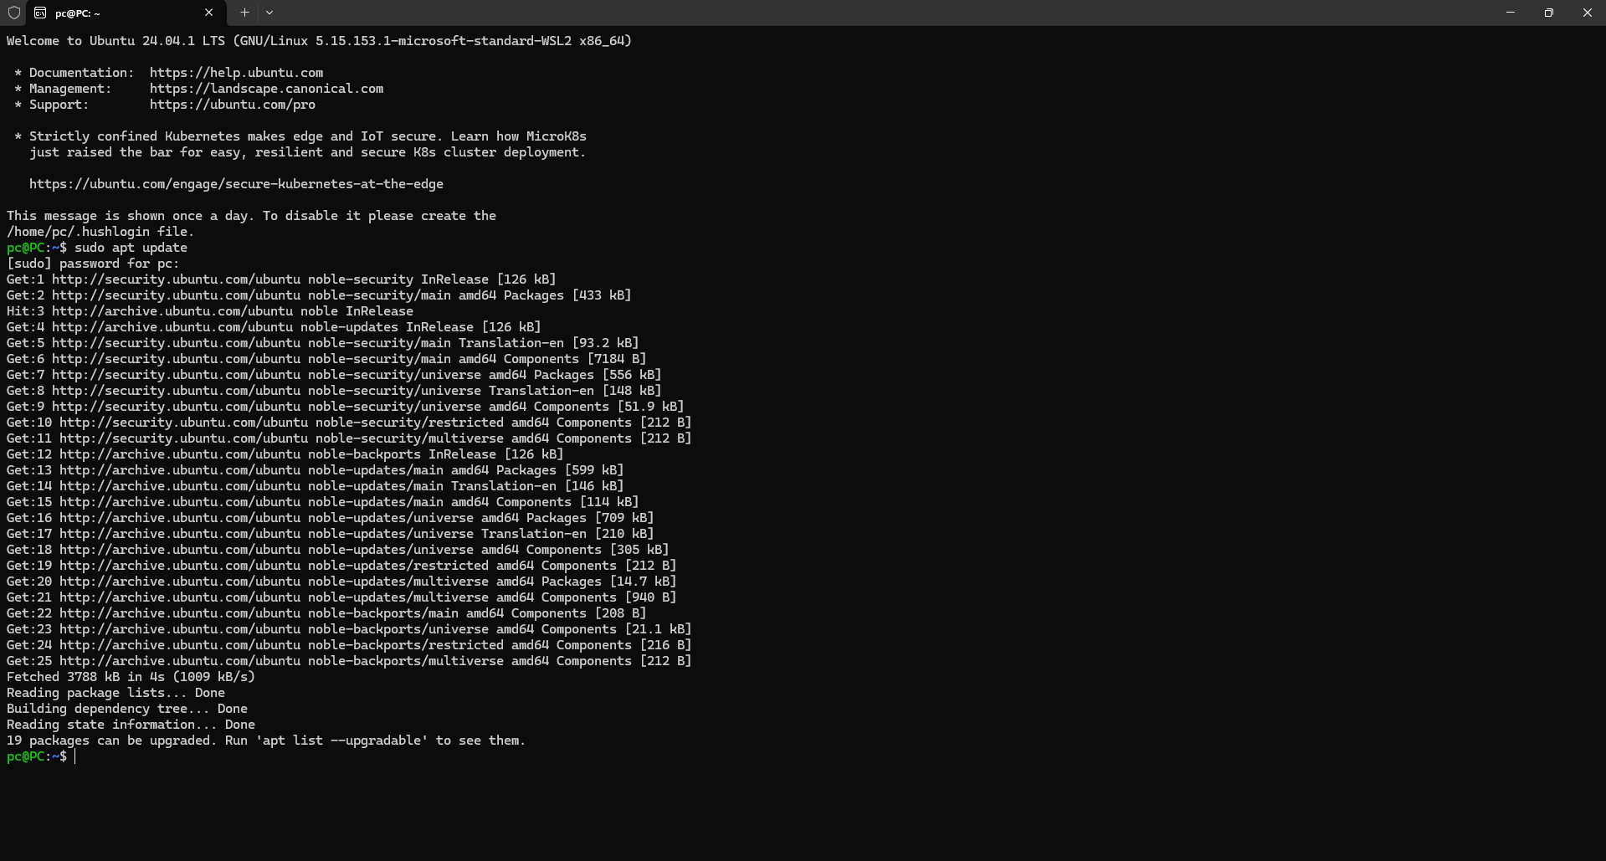

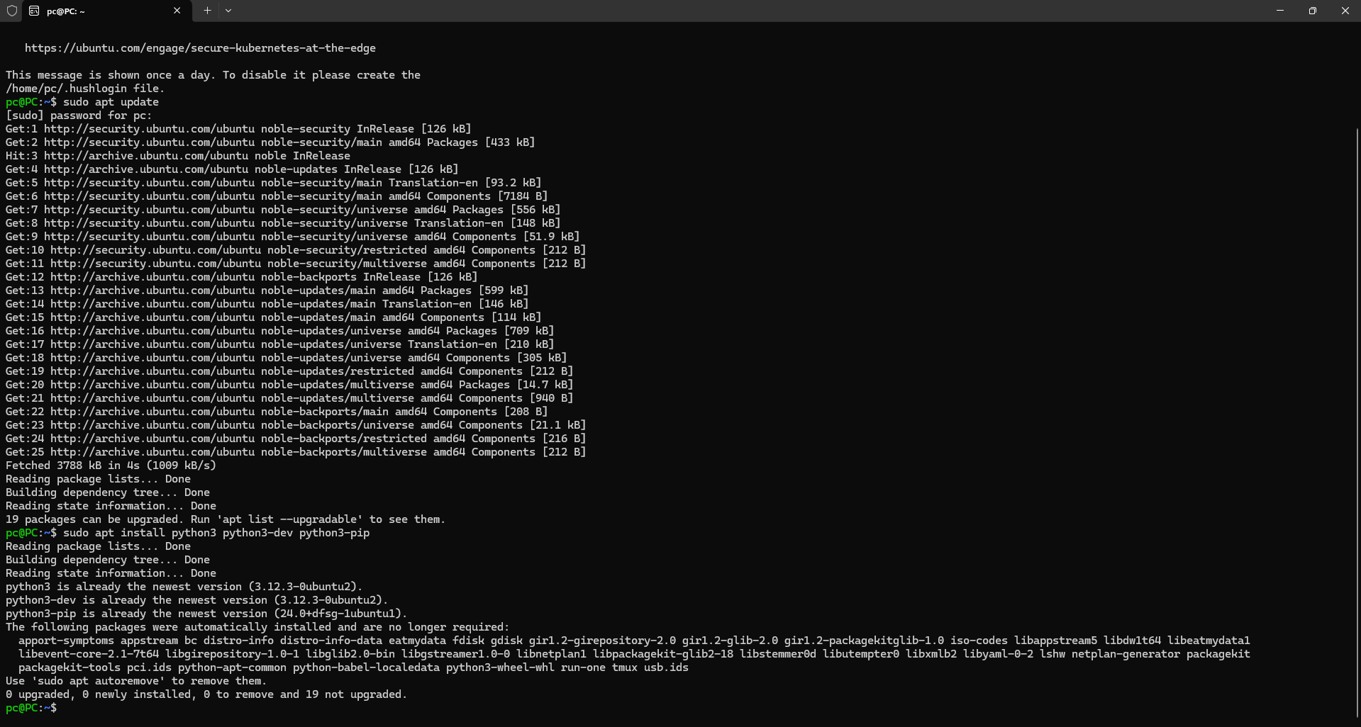

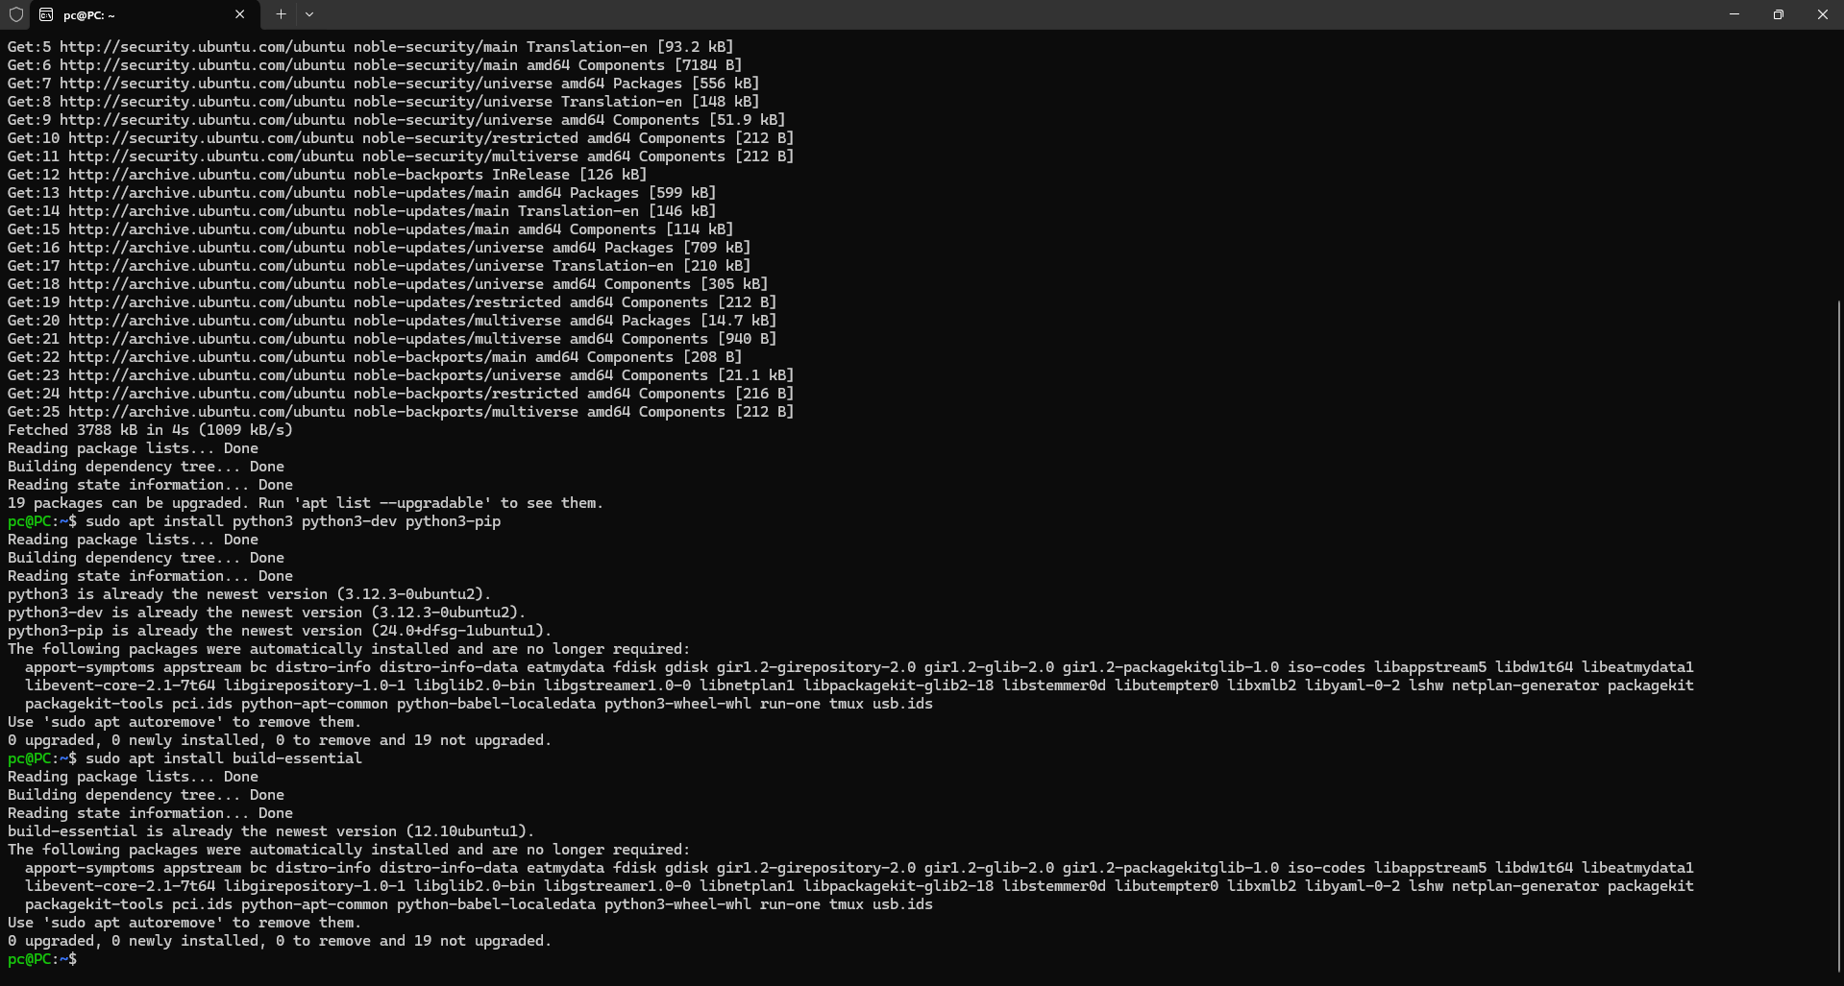

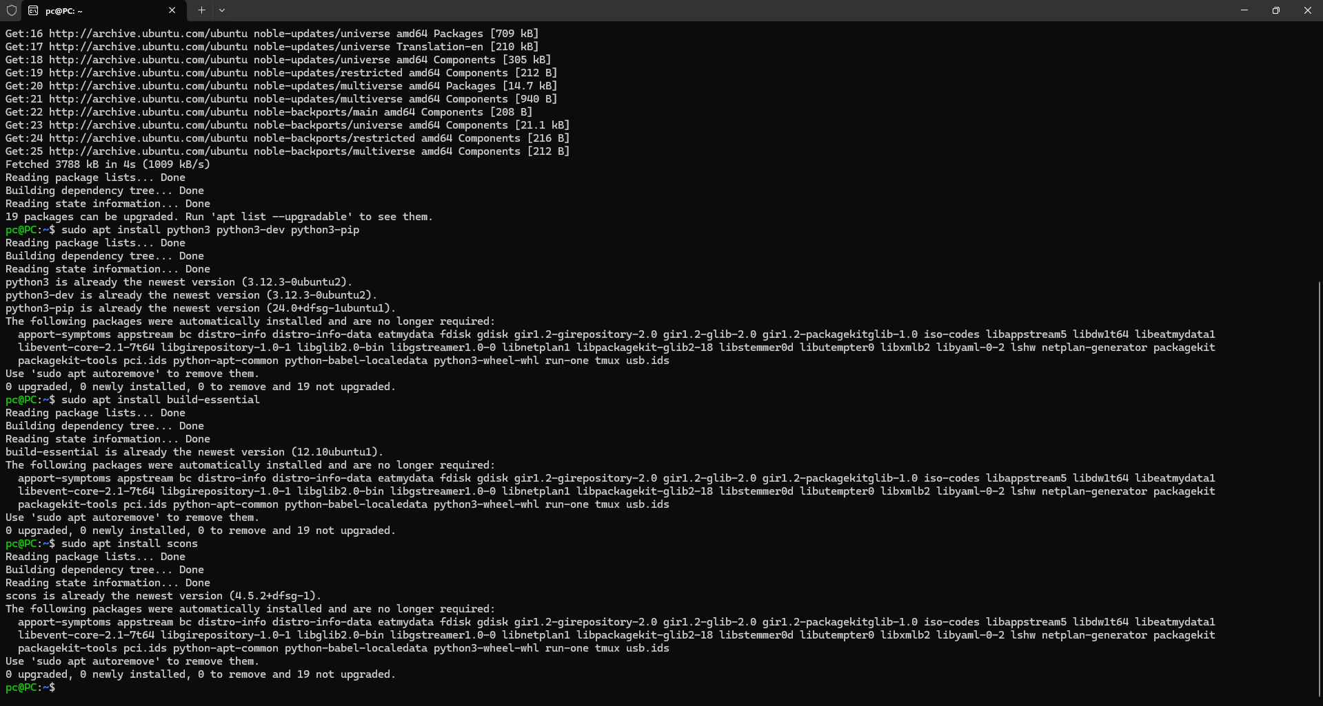

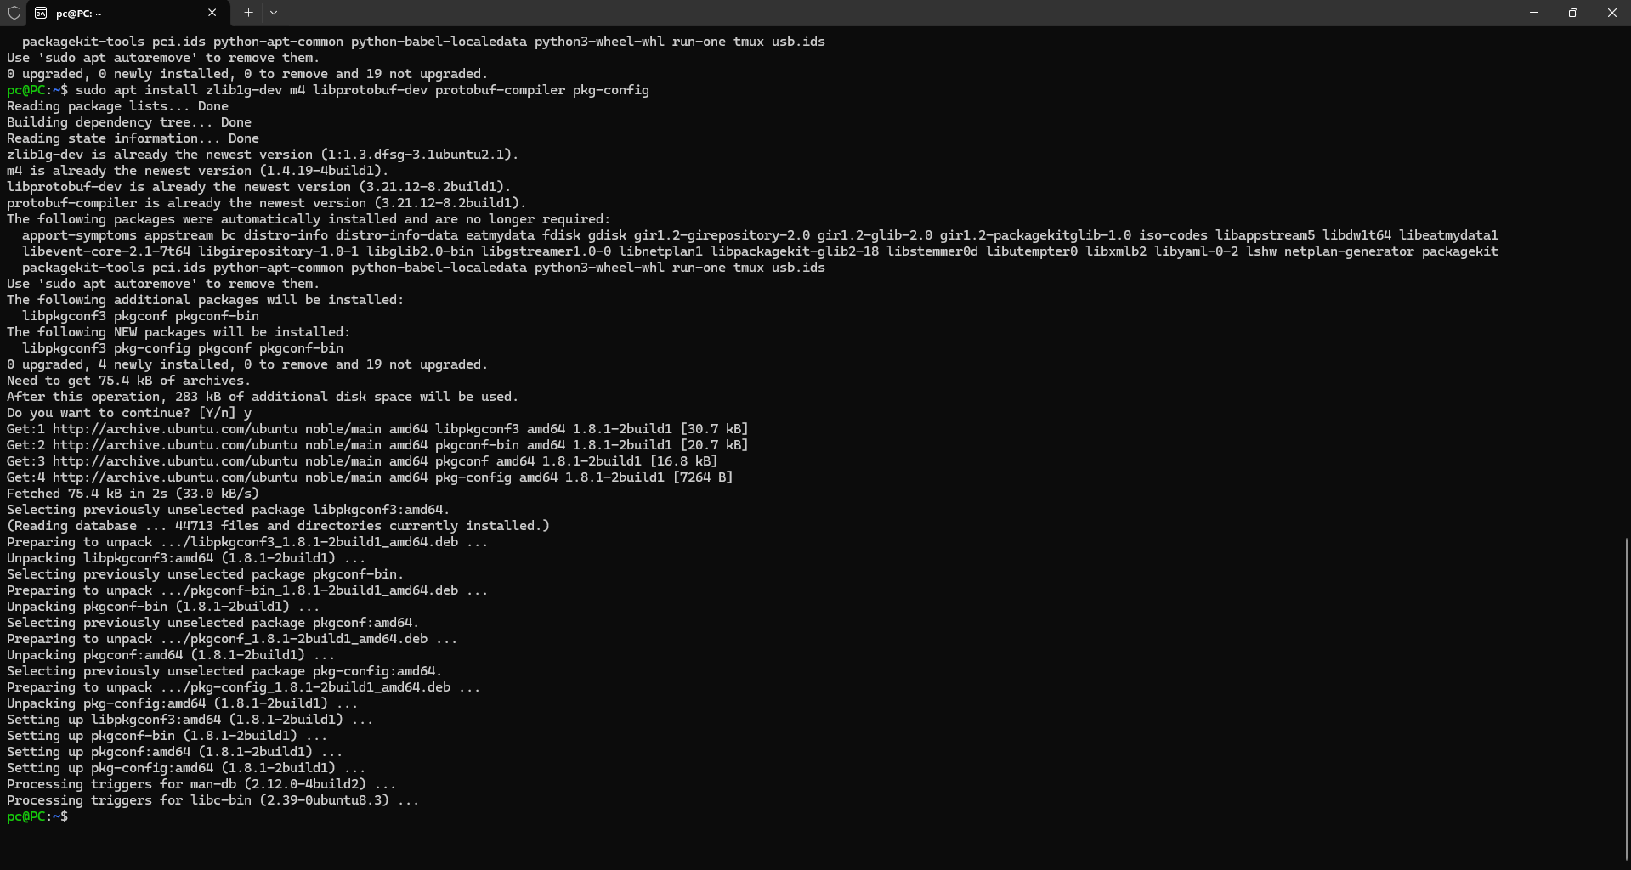

# Part 4: Building gem5

Building gem5 uses SCons to gather the source code for a certain CPU architecture. This tool lets users generate an executable version of gem5 specifically for their study interest, like simulations on the X86 or ARM architectures. If done consecutively, the command for building specifies the architecture and makes use of many CPU cores to expedite the compilation process, therefore saving a great amount of time. Simulations conducted using the resultant executable after the construction process finishes satisfactorially. Providing a great degree of adaptability for simulation situations, the executable lets researchers select many CPU models including basic atomic CPUs, complex out-of-order CPUs, and numerous cache topologies. Sometimes, nevertheless, the building process might provide difficulties like configuration mistakes or missing dependencies. Python package management mistakes are somewhat prevalent, particularly in settings where the system limits direct pip installs. Using virtual environments for Python dependencies helps to separate project-specific packages from the system's Python installation. This approach helps to keep the surroundings steady and helps to avoid problems across many forms of libraries. Recording such troubleshooting techniques not only helps others who may run into similar problems during their setup but also serves personal reference.

# Conclusion

Any computer architecture researcher must be master of technologies like GitHub and gem5. While gem5 allows thorough simulation and examination of novel architectural ideas, GitHub helps efficient version management and teamwork. This course offers a useful manual for creating a GitHub account and developing gem5, therefore arming students with the fundamental tools required for their research activities. Students will be better ready for practical research and development projects by recording their experiences and answers to possible difficulties.